**Security Camera Number Plate Analysis**

**Goal:** To identify the “NOPLATE” read from the data of security center Camera.

**Data Extraction:** We get all the data from the security center Camera, Merge them into one file using merge-csv.com and give it a significant name.

**Data Transform:** All the correction like duplicate header, null values, missing data are corrected in this phase.

**Data Load:** We connect the csv file to Tableau for further analysis of the data.

**Analysis:** We use the “Tableau” for analyzing the percentage of plate reads and no reads for one week data.

**Final Analysis results**

Here are all the results for week 2 Dec- 6 Dec 2019

Number of no plate reads vs Plate Reads for 1 week (2-6 Dec)

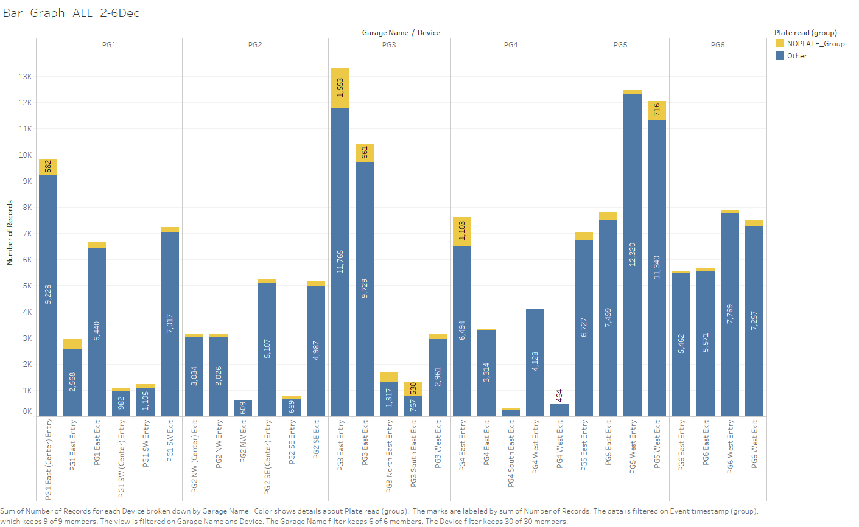

**Number of no plate reads vs Plate Reads for 1 week (2-6 Dec) NIGHT Only (6pm-6am)**

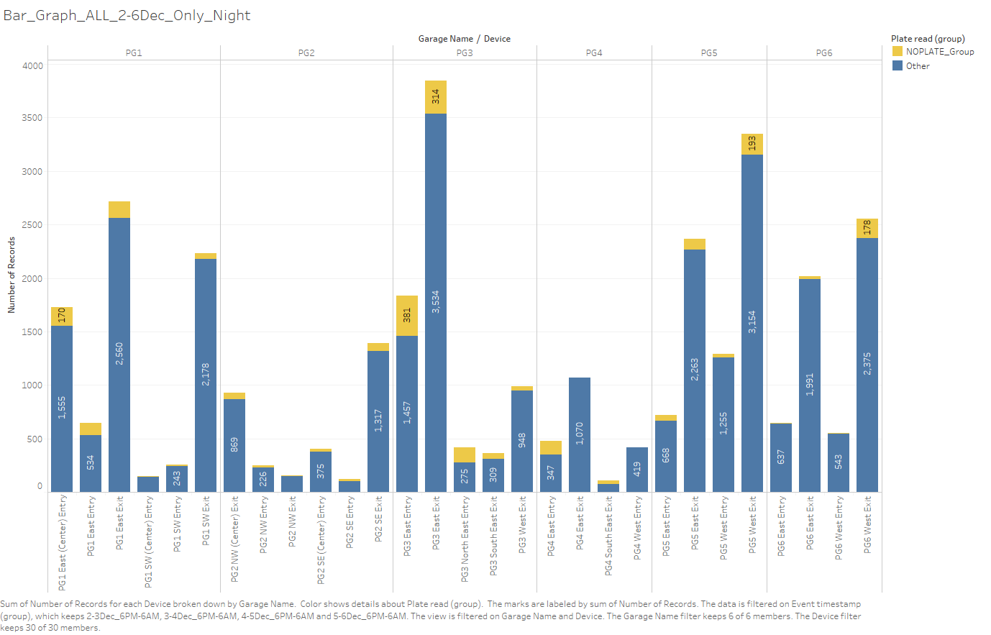

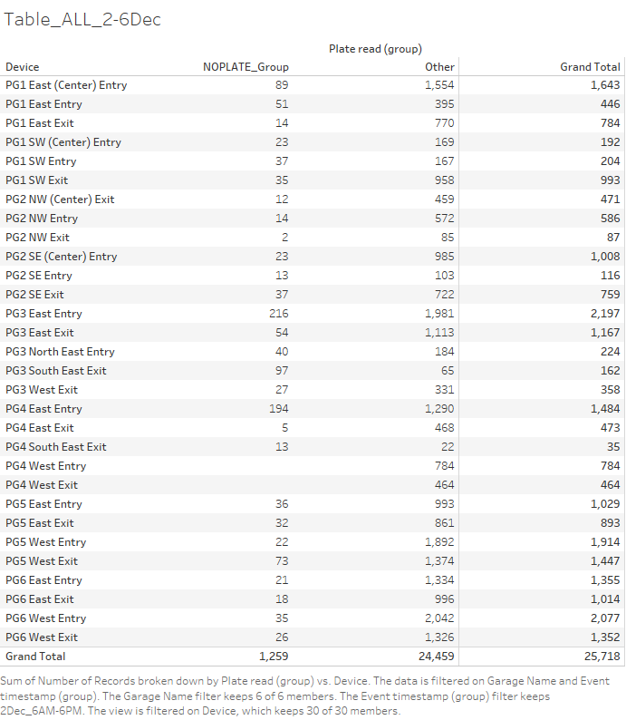

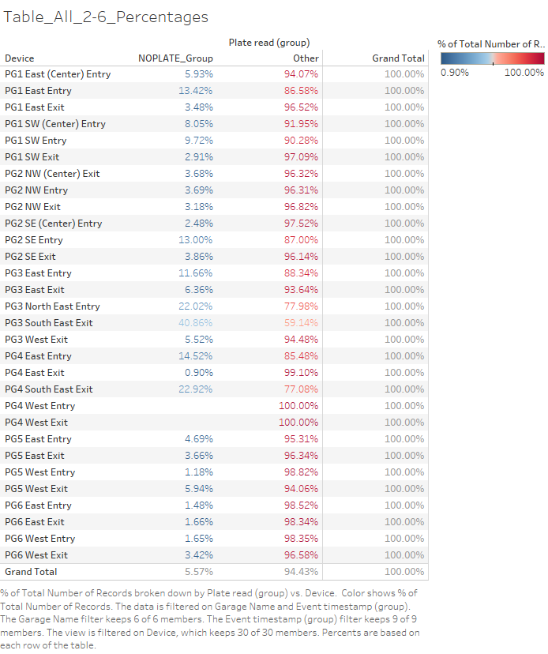

How busy Each Garages is? (Based on one week data)

PG5(39.3K)>PG3(29.8K)>PG1(29K)>PG6(26.6K)>PG2(18K)>PG4(15.8)

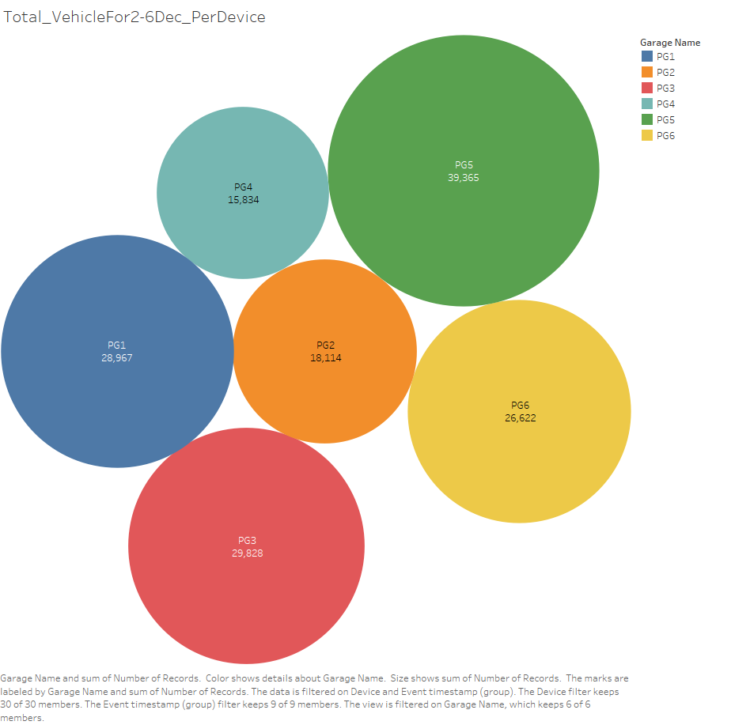

How busy Each Device is? (Based on one week data)

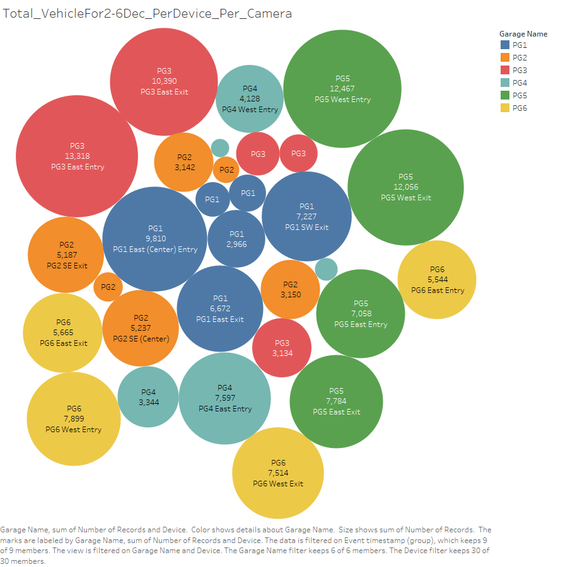

**Final Insights**

**Very Bad (% of No Plate Read>10%)**

* PG3 South East Exit(41%),
* PG4 South East Exit (23%),
* PG3 North East Entry (22%),
* PG4 East Entry (14.5%),
* Pg1 East Entry (13.5%),
* Pg2 SE Entry (13%)

**Very Good (% of no plate Read)<2%**

* PG4 West Entry (0%)
* PG4 West Exit (0%)
* PG5 West Entry (1.1%)
* PG6 East Entry (1.5)
* PG6 East Exit (1.6%)
* PG6 West Entry (1.6%)